Lab 1 – Protocols and Monitoring-HTTP

Packet Sniffers

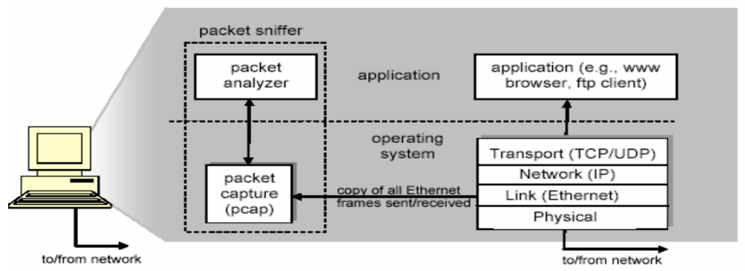
The basic tool for observing the messages exchanged between executing protocol entities is called a packet sniffer. As the name suggests, a packet sniffer captures (“sniffs”) messages being sent/received from/by your computer; it will also typically store and/or display the contents of the various protocol fields in these captured messages. A packet sniffer itself is passive. It observes messages being sent and received by applications and protocols running on your computer, but never sends packets itself. Similarly, received packets are never explicitly addressed to the packet sniffer. Instead, a packet sniffer receives a copy of packets that are sent / received from/by application and protocols executing on your machine. Figure above shows the structure of a packet sniffer.

Launch Wireshark application as an administrator. After launching wireshark click the name of an interface under Interface List, which is in the left hand side of the window, to start capturing packets on that interface. For this lab you want to capture traffic on the LAN network, so click on LAN or Ethernet interface. You can configure advanced features by clicking Capture Options. In the capture options un-select promiscuous mode.

As soon as you click the interface’s name, you’ll see the packets start to appear in real time. Wireshark captures each packet sent to or from your system. Since you have promiscuous mode disabled in your capture options, you will see packets to/from your machine. If promiscuous mode is enabled then you might other packets traversing in the network too. (This happens only if Ethernet switches in the lab are operating as hubs).

Click the stop capture button near the top left corner of the window when you want to stop capturing traffic.

Colour Coding and Packet Information

You’ll probably see packets are highlighted in different colours and for each packet some information about the packet, such as relative time, source IP address, Destination IP address, Protocol name are displayed. This list of packets is call packet list. Wireshark uses colours to help you identify the types of traffic at a glance. By default, green is TCP traffic, dark blue is DNS traffic, light blue is UDP traffic, and black identifies TCP packets with problems — for example, they could have been delivered out-of-order.

Click on one of the packets in the packet list. Now you will see more details about the packet will be displayed in another two window panes below the packet list. First one shows all the details of the packet in a human readable form while last one shows raw bytes in the packet.

Filtering Packets

If you’re trying to inspect something specific, wireshark has a filtering facility to filter in only the required packets. Filter toolbar which can be used to create filters can be seen in the fourth raw form the top of the wireshark window.

The most basic way to apply a filter is by typing it into the filter box at the top of the window and clicking Apply (or pressing Enter). For example, type “http” and you’ll see only http packets. When you start typing, Wireshark will help you auto complete your filter.

Now click on the clear button on filter toolbar to remove the filter. Now you should see all the packets in the packet list again.

Exercises

- Monitor and Decode HTTP Traffic

- Monitor and Decode HTTP Traffic

  - Close all applications except wireshark.
  - Type http in the filter box.
  - Open a web browser.
  - Type url of known http website in the address bar of the web browser. (Note that some webpages are https. Those are not suitable for our purpose)
  - Try to access the website.
  - You should see one or more http request and http response captured in wireshark.
  - Open one of the requests and examine the contents. If you look at the packet carefully you will able to see some of the contents of the web page inside the HTTP packet. Some might contain data related to images video clips etc. But if you try several different HTTP packets (may be from different TCP connections), you will see text related to web page are in the packets.
  - Identify HTTP GET request and related response.
  - Save them in a text file.
  - Identify at least 5 fields in the HTTP request and 5 fields in http response.
  - What are the values in each of the identified field?

You have to submit the HTTP GET request and the response captured by you on or before 31st Oct 2017. In the request and response each you need to mark 5 fields which you have identified. Only who submit this will be allowed to participate in lab class after this date.

